EU DECLARATION OF CONFORMITY

- This EU Declaration of Conformity relates to the following PPE (PPSS Stab Resistant Body Armour) Model No’s:

PPSS-CF-01 (manufacturer’s reference) inclusive of:

600101 – CAST KR1 SP1 Stab & Spike Panels
700130 – Covert Cover
700131 – Overt Cover
700132 – Overt Cover with Reflective Tape

- Manufactured by:

PPSS Ltd
Unit 603, Avenue D
Thorp Arch Estate
Wetherby
West Yorkshire
LS23 7FS
United Kingdom

- This declaration of conformity is issued under the sole responsibility of the manufacturer:

- Object of this declaration refers to all KR1 SP1 Body Armour models as detailed in para’1 of this declaration. Images of models referenced can be seen at Annex A. to this declaration.

- The object of the declaration described in para’4. is in conformity with the relevant Union harmonization legislation; Regulation (EU) 2016/425 of the European Parliament and of the Council of 9 March 2016 on personal protective equipment and repealing Council Directive 89/686/EEC, and appropriate additional protocol.

- The object of this declaration, models listed in para’1, is tested and certified to relevant standards, specifically;

Designated Standard: EN ISO 13688:2013
Technical Specification: 012/17 Home Office Body Armour Standard (2017)

- The notified body, BTTG Certification Services (Notified Body Identification No. 0338), has performed the Module B type-examination and issued the EU type-examination certificate (No. 523940).

Signed for and on behalf of:

PPSS Ltd
Unit 603, Avenue D
Thorp Arch Estate
Wetherby
West Yorkshire
LS23 7FS
United Kingdom

Name: Tony Welsh Position: Director of Supply, Compliance & HR Date: 01 June 2021

ANNEX ‘A’ to EU DECLARATION OF CONFORMITY

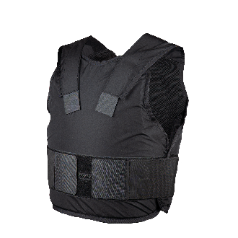
700130 – Covert Cover
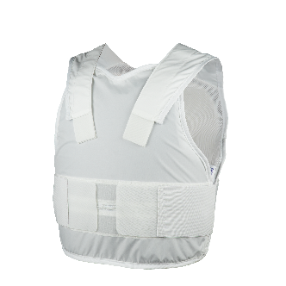

700131 – Overt Cover

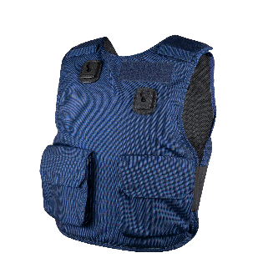
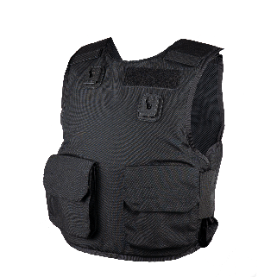

700132 – Overt Cover with Reflective Tape
